Identifying schizophrenia and other psychoses with psychological scales in the general population

Teppo Tutkija^{1,2}, Tarja Tutkija³

¹ Department of Psychiatry, Oulu University and Oulu University Hospital, Oulu, Finland;
² Institute of Health Sciences, University of Oulu, Oulu, Finland;
³ Department of Psychiatry, Tampere University Hospital, Tampere, Finland

Address for correspondence: Teppo Tutkija, Department of Psychiatry, P.O.Box 5000, 90014 UNIVERSITY OF OULU, Finland
(Phone +358 8 3156911, Fax +358 8 333167, Email: teppo.tutkija@oulu.fi)
ABSTRACT
Background. We study the predictive power and associations of several schizotypal and temperament scales with respect to schizophrenia and other psychotic disorders.
Method. Temperament and Character Inventory, Physical Anhedonia Scale, Social Anhedonia Scale, Perceptual Aberration Scale, Hypomanic Personality Scale, Bipolar II Scale, and Schizoidia Scale were included in the 31-year follow-up survey of the prospective Northern Finland 1966 Birth Cohort (N=4,926). We compared participants without any previous hospitalisations to those with previous psychoses (concurrent validity) and to those who were hospitalised due to psychoses during the eleven-year long follow-up (predictive validity). We also compared the participants with schizophrenia, other psychoses and participants with other psychiatric disorders (discriminant validity).
Results. The Perceptual Aberration Scale was the best scale for concurrent validity (Effect Size, d=1.89). Perceptual aberration (concurrent, d=0.64) and hypomanic personality (predictive, d=0.62) were best scales in terms of discriminant validity. Participants having a high score in hypomanic personality were at the highest risk for developing schizophrenic psychoses. High harm avoidance (d=1.14 for concurrent cases) was a dominant temperament characteristic in schizophrenic psychoses when compared to controls.
Conclusions. Participants with psychoses differed in most of the scales from healthy controls, and in some from participants with other psychiatric disorders. Many of the scales were useful predictors of schizophrenia and other psychoses; however, the scales were not very diagnosis-specific. These scales are probably not useful as screening instruments, but some (e.g. Perceptual Aberration Scale) can be used as intermediate phenotypes when studying schizophrenia and other psychoses.

Acknowledgements
This study has been funded by the Academy of Finland, the European Commission, and the Sigrid Jusélius Foundation.

References
Akiskal, H. S., Maser, J. D., Zeller, P. J., Endicott, J., Coryell, W., Keller, M., et al. (1995). Switching from 'unipolar' to bipolar II. An 11-year prospective study of clinical and temperamental predictors in 559 patients. Archives of General Psychiatry 52, 114–123.
Chapman, L. J., Edell, W. S., & Chapman, J. P. (1980). Physical anhedonia, perceptual aberration and psychosis-proneness. Schizophrenia Bulletin 6, 639–653.
Eckblad, M., & Chapman, L. J. (1986). Development and validation of a scale for hypomanic personality. Journal of Abnormal Psychology 95, 214–222.
Figure Receiving Operational Characteristics (ROC) curves of the scales for concurrent diagnosis (until 1997) and predictive diagnosis (1998-2005) of schizophrenic psychoses in the Northern Finland 1966 Birth Cohort.
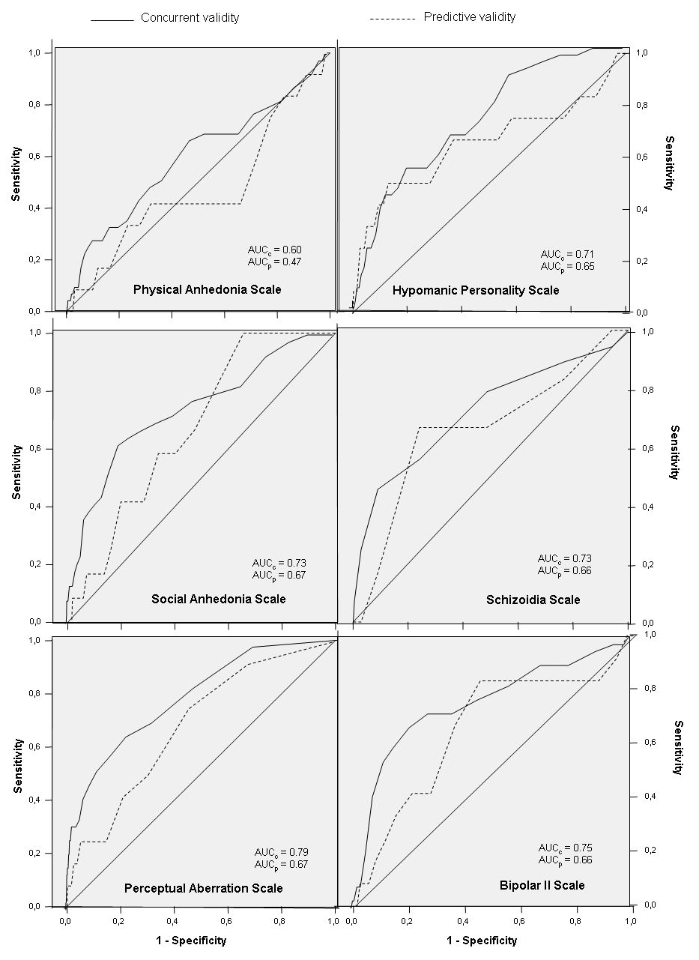
AUC_{c} = Area Under Curve (concurrent validity), AUC_{p} = Area Under Curve (predictive validity)

Table 1 Psychological scales used in the 31-year follow-up of the Northern Finland 1966 Birth Cohort.

Instrument (abbreviation) | # of Items* | Description of subjects having high scores in the scales | Reference(s)
Revised Physical Anhedonia Scale (PAS) | 61 | Lowered ability to experience physical and sensory pleasures | Chapman et al. 1976
Revised Social Anhedonia Scale (SAS) | 40 | Schizoid lack of interest in social interaction | Chapman et al. 1976; Ekcblad et al. 1982
Perceptual Aberration Scale (PER) | 35 | Have distorted perception of own body and other objects | Chapman et al. 1978
Hypomanic Personality Scale (HPS) | 48 | Energetic, upbeat, gregarious people, often able to work long hours | Eckblad and Chapman 1986
Bipolar II scale (BIP2) | 31 | May predict bipolar II disorder among unipolar subjects | Akiskal et al. 1995
Schizoidia scale (SCHD) | 7 | Minnesota Multiphasic Personality Inventory (MMPI) items that may predict schizophrenia when pooled. Subjects have for example unusual thoughts. | Golden and Meehl 1979
Temperament and Character Inventory (TCI) subscales
- Novelty Seeking (TCI-NS) | 40 | Respond with intense excitement to novel stimuli | Cloninger et al. 1993
- Harm Avoidance (TCI-HA) | 35 | Subjects with tendency to respond intensively to signals of aversive stimuli, thereby inhibiting/stopping behaviour | Cloninger et al. 1993
- Reward Dependence (TCI-RD) | 24 | Respond intensely to signals of reward | Cloninger et al. 1993
- Persistence (TCI-P) | 8 | Subjects with tendency to persevere in behaviours associated with reward | Cloninger et al. 1993

Table Mean and standard deviation of different psychological scales in the 31-year follow-up (in 1997) for those with previous hospitalisation for schizophrenic psychosis (A), other psychotic disorders (B), other psychiatric disorders (C), and healthy controls (D).

 | A)  Schizophrenia until 1997 |  |  |  | B)  Other psychotic disorders until 1997 |  |  |  | C)  Other psychiatric disorders until 1997 |  |  |  | D)  No psychiatric disorders until 1997
 |  | N | Mean | SD |  | N | Mean | SD |  | N | Mean | SD |  | N | Mean | SD
Scales
PAS |  | 29 | 18.38 | 10.19 |  | 26 | 15.77 | 7.19 |  | 276 | 15.03 | 8.04 |  | 4572 | 15.02 | 6.99
SAS |  | 29 | 15.59 | 7.34 |  | 26 | 11.42 | 5.54 |  | 271 | 11.45 | 6.83 |  | 4569 | 9.33 | 5.43
PER |  | 29 | 9.34 | 8.13 |  | 26 | 4.08 | 4.46 |  | 274 | 4.16 | 5.13 |  | 4568 | 2.24 | 3.04
SCHD |  | 29 | 4.10 | 1.76 |  | 26 | 3.31 | 1.69 |  | 274 | 3.36 | 1.56 |  | 4578 | 2.51 | 1.39
HPS |  | 29 | 17.59 | 7.08 |  | 26 | 11.42 | 5.89 |  | 273 | 14.88 | 7.99 |  | 4571 | 11.07 | 6.93
BIP2 |  | 29 | 14.55 | 4.15 |  | 26 | 12.38 | 3.92 |  | 275 | 12.73 | 4.46 |  | 4577 | 10.47 | 3.73
TCI-NS |  | 28 | 18.50 | 5.74 |  | 25 | 19.36 | 4.54 |  | 272 | 21.93 | 5.93 |  | 4534 | 20.34 | 5.86
TCI-HA |  | 28 | 21.71 | 7.10 |  | 25 | 18.44 | 6.42 |  | 272 | 17.29 | 7.12 |  | 4534 | 13.82 | 6.00
TCI –RD |  | 28 | 13.57 | 3.70 |  | 25 | 14.04 | 3.18 |  | 272 | 14.88 | 4.02 |  | 4534 | 14.74 | 3.78
TCI -P |  | 28 | 3.96 | 2.06 |  | 25 | 4.24 | 1.42 |  | 272 | 4.22 | 1.88 |  | 4534 | 4.31 | 1.74
PAS = Physical Anhedonia Scale, SAS = Social Anhedonia Scale, PER = Perceptual Aberration Scale, SCHD = Schizoidia Scale, HPS = Hypomanic Personality Scale, BIP2 = Bipolar II Scale. TCI = Temperament and Character Inventory (NS = novelty seeking, HA = harm avoidance, RD = reward dependence, P = persistence). Mean values in categories with psychiatric diagnoses are compared to controls using two-way analysis of variance (ANOVA), with diagnostic group and gender as independent variables. Statistical significant (ANOVA, p<0.05) Effect Sizes are in bold.

